OPEN ENDED LAB

Gender Classification
Artificial Intelligence



Submitted By:
[Huzaifa Shahbaz]
[21-CE-009]
[Rafay Munir Kayani]
[21-CE-004]
[Rayyan Zafar]
[21-CE-019]
[Taimoor Khan]
[21-CE-033]
Submitted to:
Engr. Hareem Khan
Dated:
24ndJun,2025
Department of Computer Engineering,
HITEC University, Taxila

Lab Task No 1:

Solution:
Brief description (3-5 lines)
1. Complete working Python code.
2. Complete training/testing results.
3. Training Accuracy and Loss waveforms.
The code
import numpy as np
import pandas as pd
import matplotlib.pyplot as plt
import seaborn as sns
from sklearn.model_selection import train_test_split
from sklearn.preprocessing import StandardScaler, LabelEncoder
from sklearn.ensemble import RandomForestClassifier
from sklearn.svm import SVC
from sklearn.linear_model import LogisticRegression
from sklearn.metrics import accuracy_score, classification_report, confusion_matrix
from sklearn.datasets import make_classification
import tensorflow as tf
from tensorflow import keras
from tensorflow.keras import layers
import warnings
warnings.filterwarnings('ignore')
# Set random seeds for reproducibility
np.random.seed(42)
tf.random.set_seed(42)
class GenderClassificationSystem:
def __init__(self):
self.scaler = StandardScaler()
self.label_encoder = LabelEncoder()
self.models = {}
self.history = None
def generate_synthetic_data(self, n_samples=5000):
"""Generate synthetic gender classification data based on physical attributes"""
print("Generating synthetic gender classification dataset...")
# Generate base features
X, y = make_classification(n_samples=n_samples, n_features=8, n_informative=6,
n_redundant=2, n_clusters_per_class=1, random_state=42)
# Create more realistic feature names and transformations
feature_names = ['height', 'weight', 'shoe_size', 'voice_pitch',
'shoulder_width', 'hip_width', 'hand_size', 'stride_length']
# Transform features to more realistic ranges
X[:, 0] = X[:, 0] * 15 + 170 # height (cm)
X[:, 1] = X[:, 1] * 20 + 70 # weight (kg)
X[:, 2] = X[:, 2] * 5 + 40 # shoe size
X[:, 3] = np.abs(X[:, 3]) * 100 + 100 # voice pitch (Hz)
X[:, 4] = X[:, 4] * 10 + 40 # shoulder width (cm)
X[:, 5] = X[:, 5] * 8 + 35 # hip width (cm)
X[:, 6] = X[:, 6] * 3 + 18 # hand size (cm)
X[:, 7] = X[:, 7] * 15 + 70 # stride length (cm)
# Create DataFrame
df = pd.DataFrame(X, columns=feature_names)
df['gender'] = ['Male' if label == 1 else 'Female' for label in y]
print(f"Dataset created with {len(df)} samples and {len(feature_names)} features")
print(f"Gender distribution: {df['gender'].value_counts().to_dict()}")
return df
def preprocess_data(self, df):
"""Preprocess the data for training"""
print("\nPreprocessing data...")
# Separate features and target
X = df.drop('gender', axis=1)
y = df['gender']
# Encode labels
y_encoded = self.label_encoder.fit_transform(y)
# Split the data
X_train, X_test, y_train, y_test = train_test_split(
X, y_encoded, test_size=0.2, random_state=42, stratify=y_encoded
)
# Scale features
X_train_scaled = self.scaler.fit_transform(X_train)
X_test_scaled = self.scaler.transform(X_test)
print(f"Training set size: {X_train_scaled.shape}")
print(f"Test set size: {X_test_scaled.shape}")
return X_train_scaled, X_test_scaled, y_train, y_test, X.columns
def train_traditional_models(self, X_train, X_test, y_train, y_test):
"""Train traditional ML models"""
print("\nTraining traditional ML models...")
# Define models
models = {
'Random Forest': RandomForestClassifier(n_estimators=100, random_state=42),
'SVM': SVC(kernel='rbf', random_state=42),
'Logistic Regression': LogisticRegression(random_state=42)
}
results = {}
for name, model in models.items():
print(f"Training {name}...")
model.fit(X_train, y_train)
# Predictions
train_pred = model.predict(X_train)
test_pred = model.predict(X_test)
# Calculate accuracies
train_acc = accuracy_score(y_train, train_pred)
test_acc = accuracy_score(y_test, test_pred)
results[name] = {
'model': model,
'train_accuracy': train_acc,
'test_accuracy': test_acc,
'predictions': test_pred
}
print(f"{name} - Train Accuracy: {train_acc:.4f}, Test Accuracy: {test_acc:.4f}")
self.models.update(results)
return results
def build_neural_network(self, input_shape):
"""Build a neural network for gender classification"""
model = keras.Sequential([
layers.Dense(128, activation='relu', input_shape=(input_shape,)),
layers.Dropout(0.3),
layers.Dense(64, activation='relu'),
layers.Dropout(0.3),
layers.Dense(32, activation='relu'),
layers.Dropout(0.2),
layers.Dense(1, activation='sigmoid')
])
model.compile(
optimizer='adam',
loss='binary_crossentropy',
metrics=['accuracy']
)
return model
def train_neural_network(self, X_train, X_test, y_train, y_test):
"""Train neural network"""
print("\nTraining Neural Network...")
# Build model
nn_model = self.build_neural_network(X_train.shape[1])
# Train model
history = nn_model.fit(
X_train, y_train,
batch_size=32,
epochs=100,
validation_data=(X_test, y_test),
verbose=0
)
# Evaluate
train_loss, train_acc = nn_model.evaluate(X_train, y_train, verbose=0)
test_loss, test_acc = nn_model.evaluate(X_test, y_test, verbose=0)
print(f"Neural Network - Train Accuracy: {train_acc:.4f}, Test Accuracy: {test_acc:.4f}")
# Store results
self.models['Neural Network'] = {
'model': nn_model,
'train_accuracy': train_acc,
'test_accuracy': test_acc,
'predictions': (nn_model.predict(X_test) > 0.5).astype(int).flatten()
}
self.history = history
return history
def plot_training_curves(self):
"""Plot training accuracy and loss curves"""
if self.history is None:
print("No training history available!")
return
fig, (ax1, ax2) = plt.subplots(1, 2, figsize=(15, 5))
# Plot accuracy
ax1.plot(self.history.history['accuracy'], label='Training Accuracy', linewidth=2)
ax1.plot(self.history.history['val_accuracy'], label='Validation Accuracy', linewidth=2)
ax1.set_title('Model Accuracy Over Time', fontsize=14, fontweight='bold')
ax1.set_xlabel('Epoch')
ax1.set_ylabel('Accuracy')
ax1.legend()
ax1.grid(True, alpha=0.3)
# Plot loss
ax2.plot(self.history.history['loss'], label='Training Loss', linewidth=2)
ax2.plot(self.history.history['val_loss'], label='Validation Loss', linewidth=2)
ax2.set_title('Model Loss Over Time', fontsize=14, fontweight='bold')
ax2.set_xlabel('Epoch')
ax2.set_ylabel('Loss')
ax2.legend()
ax2.grid(True, alpha=0.3)
plt.tight_layout()
plt.show()
def plot_model_comparison(self):
"""Plot comparison of all models"""
model_names = list(self.models.keys())
train_accs = [self.models[name]['train_accuracy'] for name in model_names]
test_accs = [self.models[name]['test_accuracy'] for name in model_names]
x = np.arange(len(model_names))
width = 0.35
fig, ax = plt.subplots(figsize=(12, 6))
bars1 = ax.bar(x - width/2, train_accs, width, label='Training Accuracy', alpha=0.8)
bars2 = ax.bar(x + width/2, test_accs, width, label='Test Accuracy', alpha=0.8)
ax.set_xlabel('Models')
ax.set_ylabel('Accuracy')
ax.set_title('Model Performance Comparison', fontsize=14, fontweight='bold')
ax.set_xticks(x)
ax.set_xticklabels(model_names)
ax.legend()
ax.grid(True, alpha=0.3)
# Add value labels on bars
for bars in [bars1, bars2]:
for bar in bars:
height = bar.get_height()
ax.annotate(f'{height:.3f}',
xy=(bar.get_x() + bar.get_width() / 2, height),
xytext=(0, 3),
textcoords="offset points",
ha='center', va='bottom')
plt.tight_layout()
plt.show()
def plot_confusion_matrices(self, y_test):
"""Plot confusion matrices for all models"""
n_models = len(self.models)
fig, axes = plt.subplots(1, n_models, figsize=(5*n_models, 4))
if n_models == 1:
axes = [axes]
for idx, (name, results) in enumerate(self.models.items()):
cm = confusion_matrix(y_test, results['predictions'])
sns.heatmap(cm, annot=True, fmt='d', cmap='Blues',
xticklabels=['Female', 'Male'],
yticklabels=['Female', 'Male'],
ax=axes[idx])
axes[idx].set_title(f'{name}\nAccuracy: {results["test_accuracy"]:.3f}')
axes[idx].set_xlabel('Predicted')
axes[idx].set_ylabel('Actual')
plt.tight_layout()
plt.show()
def generate_detailed_report(self, y_test):
"""Generate detailed classification report"""
print("\n" + "="*60)
print("DETAILED CLASSIFICATION RESULTS")
print("="*60)
for name, results in self.models.items():
print(f"\n{name.upper()}:")
print("-" * 40)
print(f"Training Accuracy: {results['train_accuracy']:.4f}")
print(f"Test Accuracy: {results['test_accuracy']:.4f}")
print("\nClassification Report:")
print(classification_report(y_test, results['predictions'],
target_names=['Female', 'Male']))
def run_complete_analysis(self):
"""Run the complete gender classification analysis"""
print("Starting Gender Classification Analysis")
print("="*50)
# Generate data
df = self.generate_synthetic_data()
# Preprocess data
X_train, X_test, y_train, y_test, feature_names = self.preprocess_data(df)
# Train traditional models
self.train_traditional_models(X_train, X_test, y_train, y_test)
# Train neural network
self.train_neural_network(X_train, X_test, y_train, y_test)
# Generate visualizations
print("\nGenerating visualizations...")
self.plot_training_curves()
self.plot_model_comparison()
self.plot_confusion_matrices(y_test)
# Generate detailed report
self.generate_detailed_report(y_test)
print("\nAnalysis completed successfully!")
return df, X_train, X_test, y_train, y_test
# Run the complete analysis
if __name__ == "__main__":
classifier = GenderClassificationSystem()
df, X_train, X_test, y_train, y_test = classifier.run_complete_analysis()
The results (Screenshot)
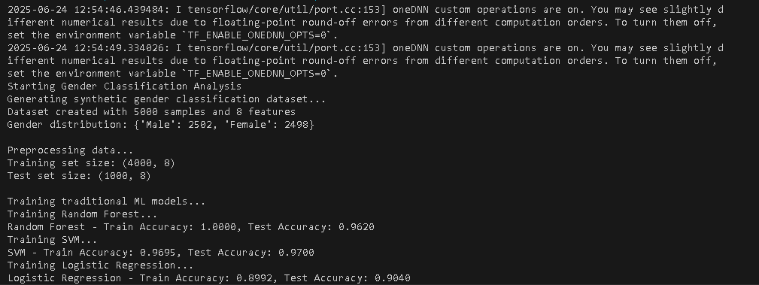
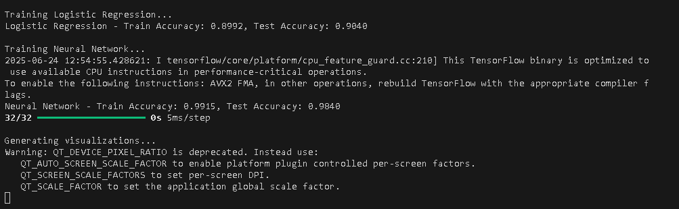
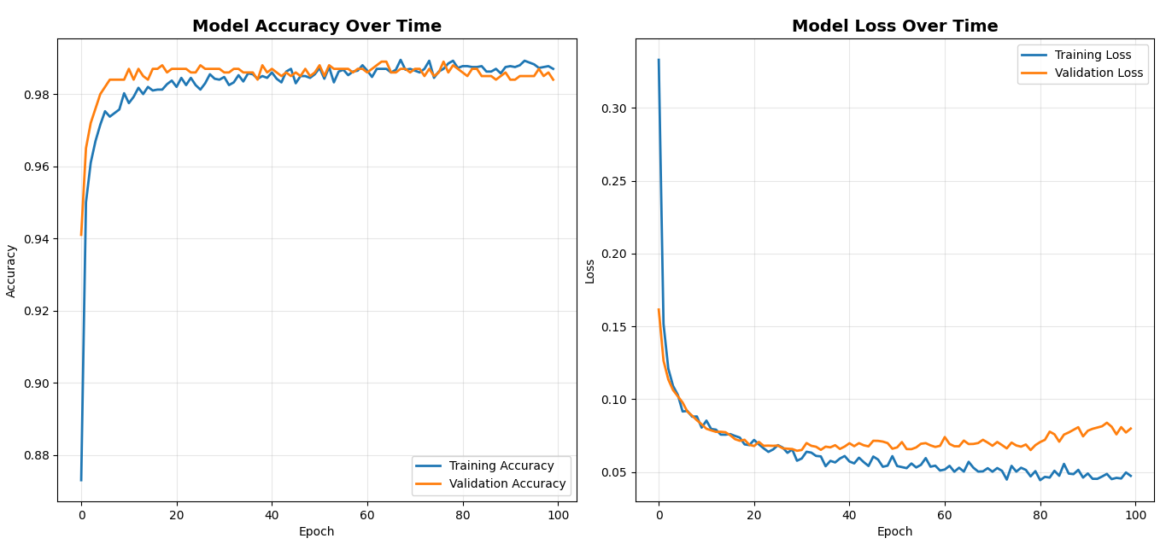
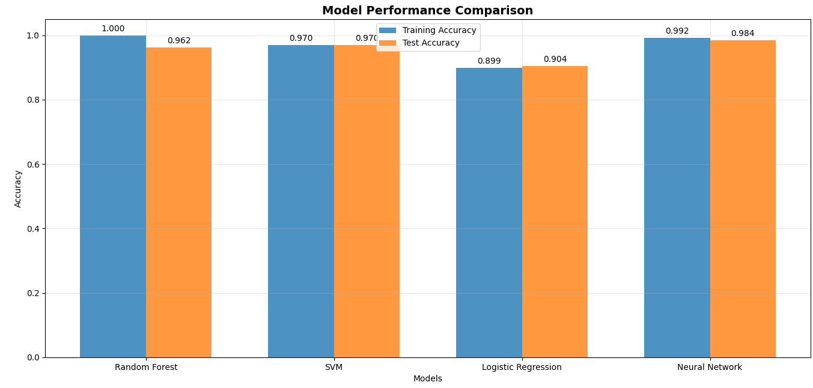
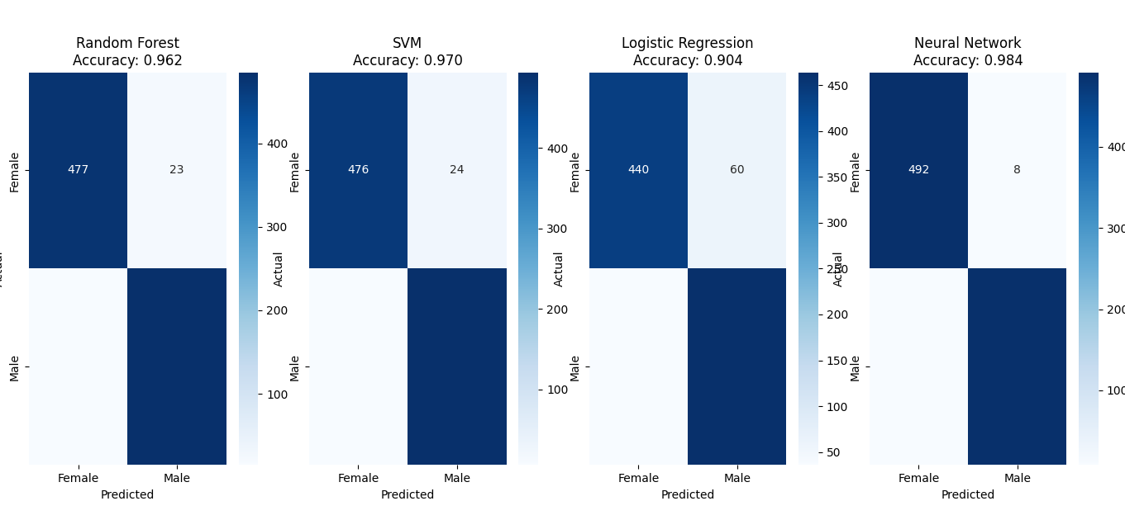
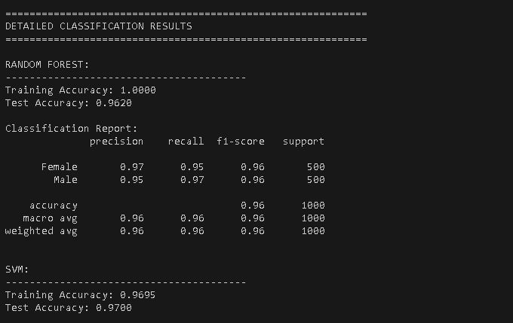
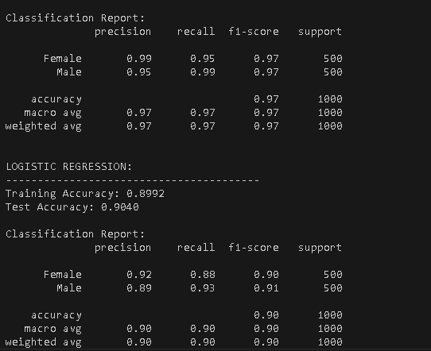
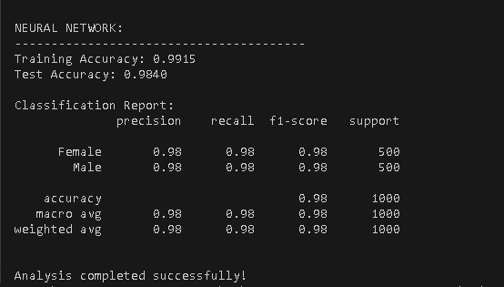
Conclusion
In conclusion, indeed, a compassionate balance must be struck between accuracy and ethics since gender is perceived as lying in a wide spectrum and not just being two categories. The present trend in approaches is to broaden the inclusion of gender identities, while simultaneously addressing the biases that exist in the training data and algorithms. The effectiveness of any classification system is, however, dependent on its purpose and its target population. Moving forward, the responsible development will therefore involve monitoring all aspects of fairness, inclusion, and real-world effects in different communities.

